DBMS Practical No.: 22

**Name: yash ajay magar**

**PR 22 * Implement PL/SQL program based on Exception Handling (Pre-defined exceptions) application**

Exercise:

1. Write a PL/SQL program that asks the user to input two numbers and divide the first number by the second. Handle the predefined exception for division by zero and display an appropriate message if it occurs.

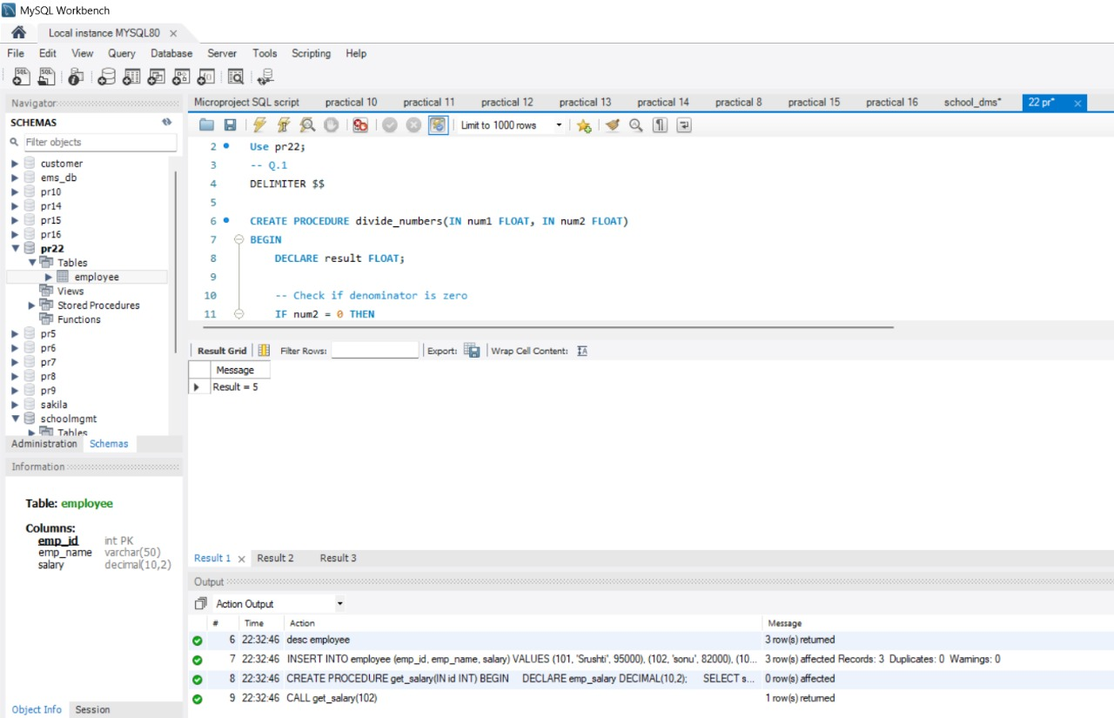

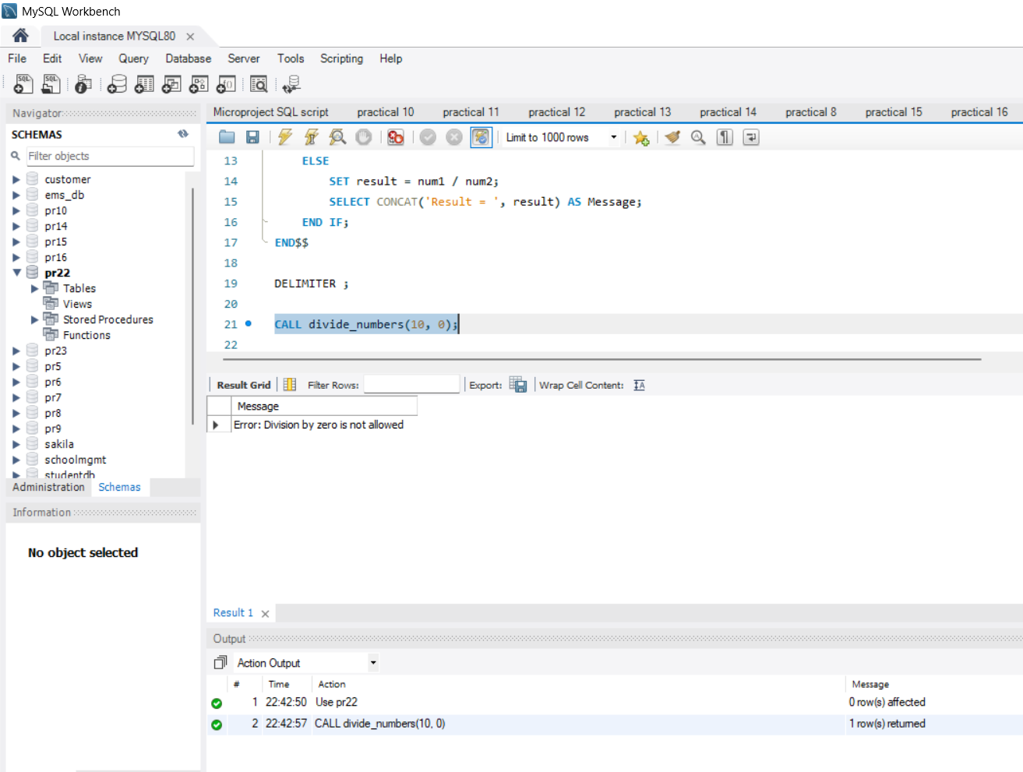

1. Write a PL/SQL program that retrieves the salary of an employee based on employee ID (emp_id). If the employee ID does not exist in the database, handle the NO_DATA_FOUND exception and print a message saying, "Employee ID not found."

